

**UNIVERSITY KUALA LUMPUR**

**MALAYSIAN INSTITUTE OF INFORMATION TECHNOLOGY**

**SOFTWARE CONFIGURATION MANAGEMENT L01**

**PROPOSAL MINI PROJECT: PET ADOPTION LISTING APP (PAL)**

**PREPARED BY:**

|  |  |  |
| --- | --- | --- |
| **NO.** | **NAME** | **STUDENT ID NO.** |
| **1** | **MOHD ADRY IERFAN BIN MOHD YAZAM** | **52213118241** |
| **2** | **AMIRUL AZIZ BIN ZAHARUDIN** | **52213118269** |

**PREPARED FOR:**

**MS. NURUL SYARAZ BT. AZMANUDDIN**

**SUBMISSION DATE:**

**9 MARCH 2020**

# **INTRODUCTION**

A pet is like a family member. Having a pet not only cheers up the family but it also teaches the responsibility of raising and caring for a living being to the adopter. Adopters would often time visit nearby animal shelter or pet shop to adopt their would-be family member. Once there, there is a wide variety of pets to choose from. Soon after, the adopters found the pet to be added to their family and sign agreement/payment to adopt the pet. Meanwhile, several pet owners may find themselves in a situation where they can no longer care for their pet or that their beloved pet has given birth to many babies.

Pet Adoption Listing (PAL) seeks to eliminate the need for a physical visitation for pet adopters by making the process doable online and help other pet owners to easily find their pet a new family to be taken care of. The project will allow pet owners to put up their pets for adoption by listing it online on a centralized platform. Meanwhile, pet adopters can look for pets more easily through the online platform.

Pet Adoption Listing shortened as PAL, is an app with the sole purpose of finding a new family for a pet to stay with. Everyone can use it to find a pet to adopt of their choosing for free. Once the agreed parties have meet up, the user will need to sign an adoption paper and pay the adoption fees. After that, the user is free to bring home their new family members! Allows people to look up available adoptions. Allows pet owners to list pets to be adopted. Pet owners can upload images of their pet onto the app when listing their adoption. Users can message between each other to communicate and set up a date to meet up.

# **OBJECTIVE**

**The purpose of the Pet Adoption Listing App (PAL):**

* Create a platform that allows the process of pet adoption.
* Make the process of applying for adoption faster and easier.
* Clear understanding of pet adoption process and its functionality so the correct implementation can be done.
* Create an interaction process between adopters and owners to communicate with ease and clearly.

# **Problem Statement**

**There are multiple problems faced by both pet adopters and pet owners.**

* Pet adopters must physically visit an animal shelter or pet store.
* Pet adopter’s selection is limited to that shelter or store.
* Pet owners must distribute their adoption through physical means.
* Adoption process are long, mainly application forms and it is processing can be time consuming.
* There is no method of viewing the selection of pet online.

# **PROJEC SCOPE**

* This system application was developed to allow the adopters to look up any available pet to be adopted which is they can see the list of pets to be adopted.
* The system allows the pet owner to upload images of their pet onto the app when listing their adoption.
* The system application allows the users can message each other to communicate and set up a date to meet up.

# **PROJECT CURRENT MODULE**

# **FUNTIONAL SYSTEM**

* View List and Details of the Pet
* Interaction Between Other Users
* Make an Appointment.
  1. **ACTOR**

**The actors include the following:**

* Pet Owner
* Pet Adopter
* System
  1. **ACTOR TASK**

**Pet Owner**

* Create an account
* Create an adoption and lost pet
* Interact with the Pet Adopter

**Pet Adopter**

* Create an account
* Create their own profile
* View and find the list of the pet
* Interact with the Pet Owner

**System**

* Hold all the user’s database

# **SOFTWARE MODELLING**

# **USE CASE DIAGRAM**

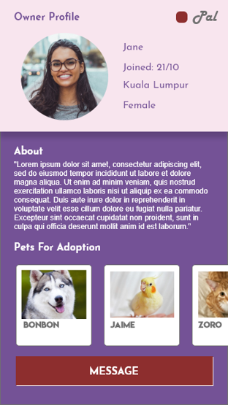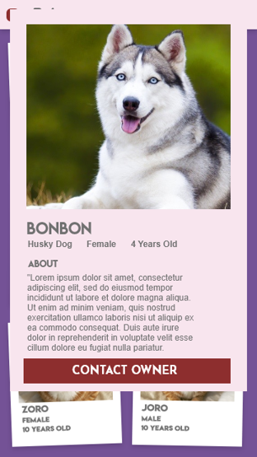**UI Design**

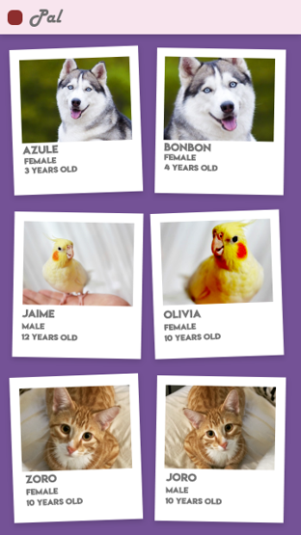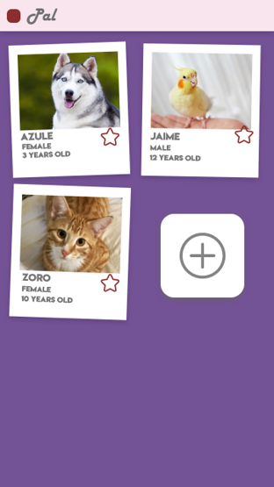

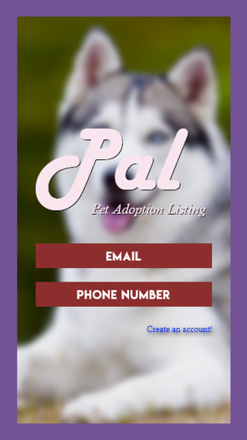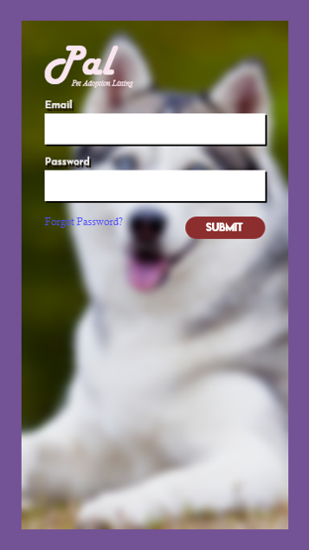

# **SPECIFICATIONS**

**Hardware Requirements**

**Developer Requirements:**

1. Processor Ryzen 5 2600
2. RAM 8 GB (minimum)
3. Input Devices: Mouse and Keyboard
4. Output Devices: 24-inch 1080p Full HD Monitor

**Target User Requirements:**

1. Smartphone running Android 8.0 and above.
2. Smartphone must have 4GB RAM.

**Software Requirement:**

**Developer Requirements:**

1. Visual Studio Code
2. Android Studio
3. MySQL
4. Windows 10

# **LIMITATION OF CURRENT PROJECT**

* The Pet Adoption Listing (PAL) system provide privacy setting option to the user.
* The Pet Adoption Listing (PAL) system should ensure the safety of all information given by the user
* The Pet Adoption Listing (PAL) system must prevent inappropriate content by users.
* The Pet Adoption Listing (PAL) system does not support any language other than English

# **FUTURE ENHANCEMENT**

* The system is developed with the intrusion of future expansion of the concern.
* New UI interfaces that can see as a highly user friendly.
* The concern can go for any future developments, as per their needs. If so, they can easily develop the modules and integrate with the existing system.
* The system will be improvised the features of the application.

# **CONCLUSION**

The system should be a convenient to the adopter that would often time visit nearby animal shelter or pet shop to adopt there would be family member also several pet owners may find themselves in a situation where they can no longer care for their pet or that their beloved pet has given birth to many babies. The system is providing the platform for the pet adopters by making the process doable online and help other pet owners to easily find their pet a new family to be taken care of allow pet owners to put up and look up easily their pets for adoption by listing it through online on a centralized platform. The system application sole purpose of finding a new family for a pet to stay with and to eliminate the need for a physical visitation for the pet owner.